Capstone Project Weekly Progress Report
Semester | Fall-2024 Semester 3rd
Course Code | AML-3406
Section | Section 1
Project Title | Car Damage Detection
Group Name | Group B
Student names/Student IDs | Sakshi (C0908000)  Bansil Patel (C0912873)  Harsh Mohile (C0912872)  Meet Patel (C0910378)  Rachit Bhatt (C0902810) – TL
Reporting Week | Week 2
Faculty Supervisor | William Pourmajidi

Grade the level of collaboration from different aspects between team members:
(use: good, medium, below expectation)
Sakshi | Bansil Patel | Harsh Mohile | Meet Patel | Rachit Bhatt
Good | Good | Good | Good | Good

Tasks outlined in the previous Weekly Progress Report for this reporting week at the individual level and group level
  - Individual tasks (each team member)
Sakshi: Document the proposal with proper formatting and make project icon.
Bansil Patel: Research project domain and define resource allocation.
Harsh Mohile: Study on ML-Ops.
Meet Patel: Select the dataset.
Rachit Bhatt: Configure GitHub.
2.2 Your team’s tasks
- Trailing with various datasets and finalizing one for the project.
- Researching on Computer Vision for Image Processing.
- Configuring GitHub and initiating working on ML-Ops.
- Decorate the project by creating an appropriate icon and structuring the reports.

Progress made in Reporting Week at an individual level and group level
  - Individual progress
Sakshi: Developed an appropriate icon for the project and learned GitHub.
Bansil Patel: Researched multiple project domains and defined their challenges and scope.
Harsh Mohile: Studied ML-Ops.
Meet Patel: Explored various datasets and found a dataset appropriate for the project.
Rachit Bhatt: Initiated GitHub configuration for the project.
  - Your team’s progress
- Explored various datasets and picked the one with more appropriate images.
- Initiated the research on Computer Vision.
- Initiated the GitHub configuration for the project management.
- Implemented a project icon.

The areas/tasks you could not make progress and/or complete as scheduled or the difficulties encountered in this reporting week at individual level and group level.
  - Individual project blockers
Sakshi: A lot of time was consumed when using AI for idealizing project icons.
Bansil Patel: Understanding the concept of Edge Detection.
Harsh Mohile: Confused in the CI/CD pipeline implementation in GitHub.
Meet Patel: Managing datasets due to low storage space and huge dataset size to accommodate one at a time.
Rachit Bhatt: Creating and configuring branch rulesets.
  - Your team’s project blockers
- Identifying the most current and relevant project topics was particularly challenging, as it involved extensive research and evaluation.
- Finding appropriate algorithms, datasets, and deployment standards required careful consideration to ensure they met our project needs.

Tasks to be completed in next week at individual level and group level
  - Individual tasks
Sakshi: Defining phases of project and analyzing post requirements of project.
Bansil Patel: Practicals of learning – Computer Vision.
Harsh Mohile: Research on Deployment Platforms.
Meet Patel: Learning GitHub Management.
Rachit Bhatt: Creating demo for CI/CD Pipeline.
  - Your team’s tasks
- Initiate work on the project concepts.
- Understand the suitable deployment platforms.

Include the tasks from your sprint planning (Github/Zenhub) for the present period.
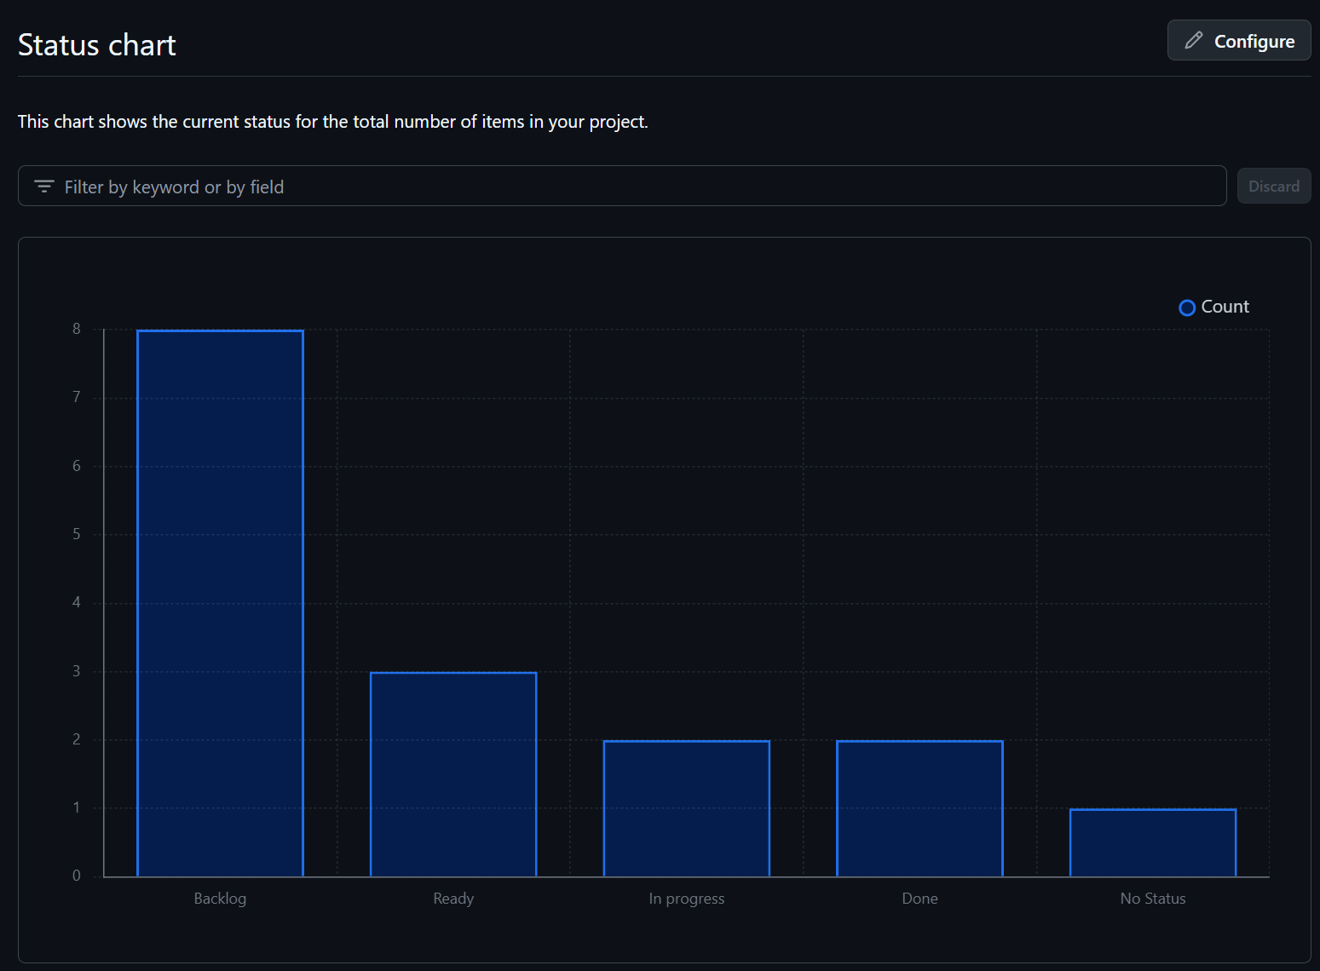
Figure 1: Status Chart of GitHub Issues in Milestone

Include charts/graphs (e.g., burn down charts) from your project management tool (Github/Zenhub) that shows your progress for the period of this report.
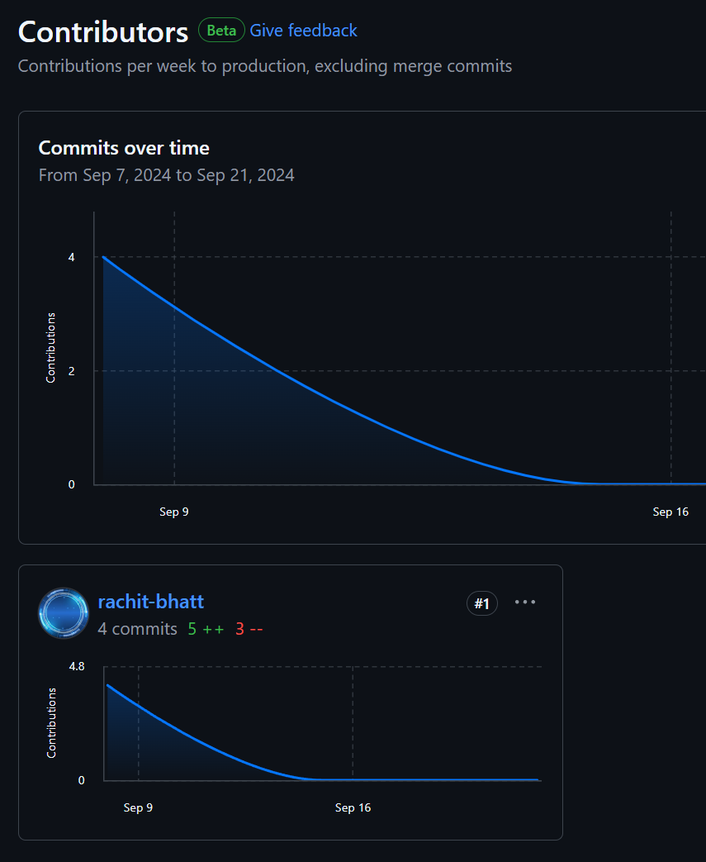
Figure 2: Highest Contributor of the Week

Include a note and address to your project Github with list of codes uploaded/updated on Github in this reporting week.
GitHub: https://www.github.com/rachit-bhatt/Capstone-Project
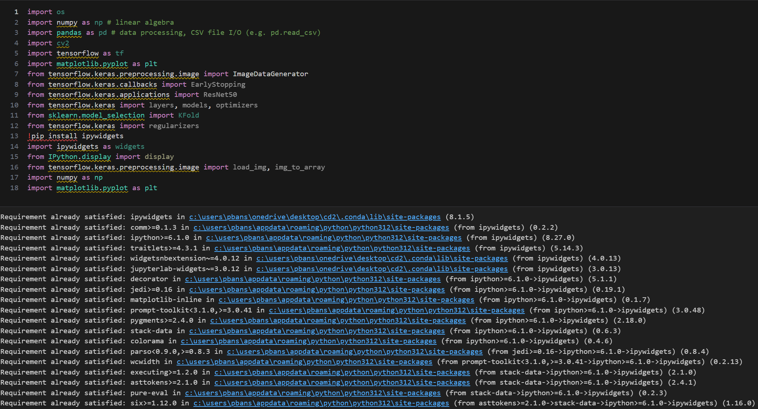
Figure 3: A few Libraries applied on Sample Dataset.
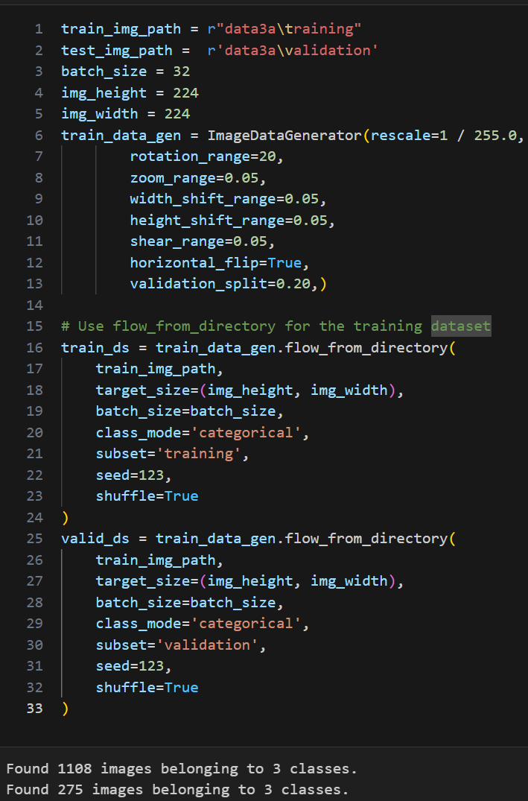
Figure 4: Loading Images from a Sample Dataset.

